Regie Pineda

Homework #5

CSS 422

Dr. Ahmed Awad

Dec 1st, 2019

Q1. (6 points) A full-adder is a combinational circuit that forms the arithmetic sum of three input bits. It consists of three inputs, x, y, z, and two outputs, C and S. Two of the input, that is, x and y, represent the two significant bits to be added. The third input, z, represents the carry from the previous lower significant position. The output S denotes the sum of two bits and C denotes carry. Answer the following sub-questions.

1) Construct a truth table for the Full-Adder

|  |  |  |  |  |
| --- | --- | --- | --- | --- |
| X | Y | Z | S | C |
| 0 | 0 | 0 | 0 | 0 |
| 0 | 0 | 1 | 1 | 0 |
| 0 | 1 | 0 | 1 | 0 |
| 0 | 1 | 1 | 0 | 1 |
| 1 | 0 | 0 | 1 | 0 |
| 1 | 0 | 1 | 0 | 1 |
| 1 | 1 | 0 | 0 | 1 |
| 1 | 1 | 1 | 1 | 1 |

2) Based on the truth table, construct a K-map for the output S and derive a Boolean equation using K-map. Make the equation as simple as possible.

|  |  |  |  |  |
| --- | --- | --- | --- | --- |
| S | ~X~Y | ~XY | XY | X~Y |
| ~Z |  | 1 |  | 1 |
| Z | 1 |  | 1 |  |

**S = XYZ + X~Y~Z + ~XY~Z + ~X~YZ**

3) Based on the truth table, construct a K-map for the output C and derive a Boolean equation using K-map. Make the equation as simple as possible.

|  |  |  |  |  |
| --- | --- | --- | --- | --- |
| C | ~X~Y | ~XY | XY | X~Y |
| ~Z |  |  | 1 |  |
| Z |  | 1 | 1 | 1 |

**C = XY + ZX + YZ**

4) By algebraic manipulation, show that S can be expressed as the exclusive-OR of the three input variables. That is, show that, S = x XOR y XOR z.

S = X ⊕ Z ⊕ Y

= (~(X⊕Y)Z)+(X ⊕Y)~Z)

= (~(X~Y+~XY)Z)+((X~Y+~XY)~Z)

= (X~Y~Z+~XY~Z)+(~(X~Y+~XY)Z)

= (~(X~Y)*~(~XY))Z+~XY~Z+X~Y~Z

= ((X+~Y)*(~X+Y))Z+~XY~Z+X~Y~Z

= (X~X+XY+~X~Y+Y~Y)Z + ~XY~Z + X~Y~Z

= (XY+~X~Y)Z+~XY~Z + X~Y~Z

= XYZ + ~X~YZ+~XY~Z+X~Y~Z

5) By algebraic manipulation, show that C can be expressed as the following term C = xy + (x XOR y)z.

XY + (X⊕Y)Z = XY + (X~Y+~XY)Z

= XY + X~YZ+~XYZ (Note: XY = XYZ + XY~Z)

= XYZ + XY~Z+X~YZ+~XYZ

= X(YZ+Y~Z+~YZ)+~XYZ

= X(Y+Z) + ~XYZ (Note: Y = YZ + Y!Z = Y(Z+!Z) = Y; Z = YZ + Y!Z, so YZ +Y!Z +YZ+!YZ then YZ + YZ = YZ)

= XY+XZ+~XYZ+XYZ (Note: Since XY + XZ is here XYZ is logically inferred as here)

= XY +XZ + YZ(X+~X)  
= XY+XZ+YZ

6) Based on 4) and 5), draw a circuit for the full-adder in Logisim simulator, attach the image file and submit the circuit file!

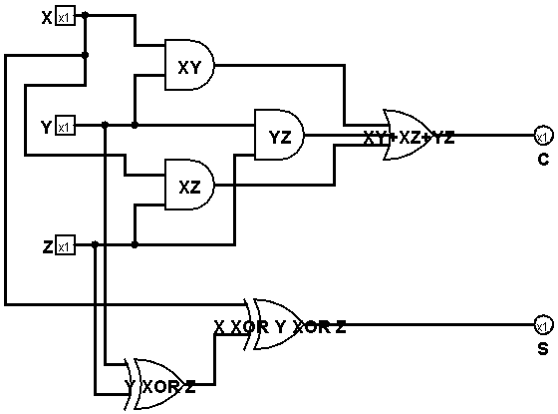

Q2. (6 points) The following sequential circuit includes a full-adder (described in the previous question). Inputs are X, Y and carry-in, and outputs are the next state of S and Q.

1) Implement the sequential circuit in Logisim simulator and submit the circuit file.

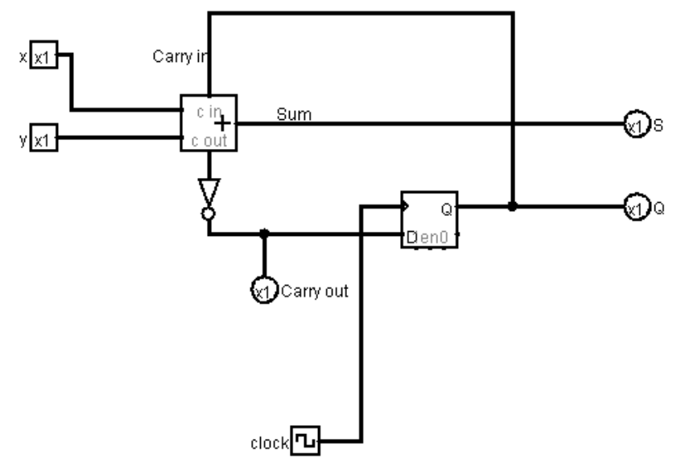

2) Complete the following truth table for the following sequential circuit: Note that the Carry out signal is an output, not the an input. The carry in signal is the same as the Q. You can change the Carry-in bit by clicking the D-FF.

|  |  |  |  |  |  |  |
| --- | --- | --- | --- | --- | --- | --- |
| X | Y | Carry-in  (or Q before clock) | S (before clock) | Carry-out (before clock) | S (after clock) | Carry-out (after clock) |
| 0 | 0 | 0 | 0 | 1 | 1 | 1 |
| 0 | 0 | 1 | 1 | 1 | 1 | 1 |
| 0 | 1 | 0 | 1 | 1 | 0 | 0 |
| 0 | 1 | 1 | 0 | 0 | 1 | 1 |
| 1 | 0 | 0 | 1 | 1 | 0 | 0 |
| 1 | 0 | 1 | 0 | 0 | 1 | 1 |
| 1 | 1 | 0 | 0 | 0 | 0 | 0 |
| 1 | 1 | 1 | 1 | 0 | 0 | 0 |

Q3. (4 points) A sequential circuit has one D flip-flop and one JK flip-flop, two inputs x and y, and one output z. A is the output of D flip-flop, and B is the output of JK-flip-flop; A and B together form the "output state" of the circuit. The flip-flop input equations and the circuit output are as follows. Here DA is the D input of the D-flip flop of A, and JB, KB is the J and K input of the JK-flip flop of B.

DA = ~xy + yB

JB = ~yB + xy

KB = xB + ~yA

z = x+~xy

1) Draw the logic diagram of the circuit and test it with Logisim. Please attach the circuit image and the generated table! Please also submit the circuit file!

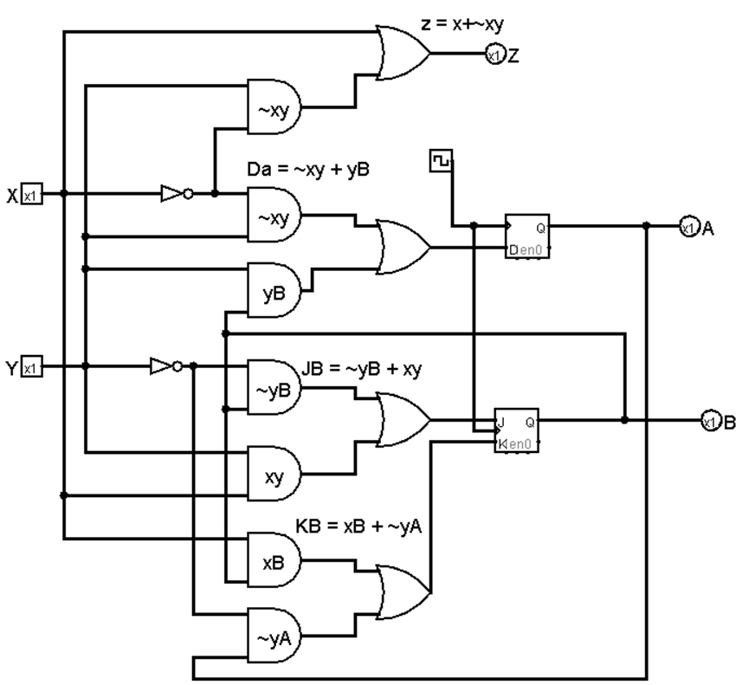

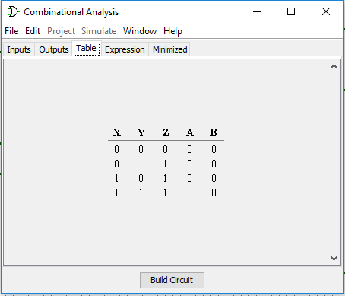

2) Construct a state diagram of this circuit.

Note: Submitted in PDF file separately

Q4. (10 points) Design a system with the following state changes: This is a sequential circuit with three flip-flops. The state sequence is changed with a clock as in the order of, 111, 010, 100,110, 001, 011, 101, 000, 111 and repeat. Use JK flip-flops.

1) Draw a state diagram.

Note: Submitted in PDF file separately

2) Construct an excitation table.

|  |  |  |  |  |  |  |  |  |  |  |  |
| --- | --- | --- | --- | --- | --- | --- | --- | --- | --- | --- | --- |
| **A** | **B** | **C** | **At+1** | **Bt+1** | **Ct+1** | **Ja** | **Ka** | **Jb** | **Kb** | **Jc** | **Kc** |
| **0** | **0** | **0** | **1** | **1** | **1** | **1** | **x** | **1** | **x** | **1** | **x**  page6image49640 |
| **0** | **0** | **1** | **0** | **1** | **1** | **0** | **x** | **1** | **x** | **x** | **0** |
| **0** | **1** | **0** | **1** | **0** | **0** | **1** | **x** | **x** | **1** | **0** | **x** |
| **0** | **1** | **1** | **1** | **0** | **1** | **1** | **x** | **x** | **1** | **x** | **0** |
| **1** | **0** | **0** | **1** | **1** | **0** | **x** | **0** | **1** | **x** | **0** | **x** |
| **1** | **0** | **1** | **0** | **0** | **0** | **x** | **1** | **0** | **x** | **x** | **1** |
| **1** | **1** | **0** | **0** | **0** | **1** | **x** | **1** | **x** | **1** | **1** | **x** |
| **1** | **1** | **1** | **0** | **1** | **0** | **x** | **1** | **x** | **0** | **x** | **1** |

3) Draw K-maps and derive Boolean equations using K-maps. Make the equations as simple as possible.

|  |  |  |  |  |  |  |  |  |  |
| --- | --- | --- | --- | --- | --- | --- | --- | --- | --- |
| JA | ~A~B | ~AB | AB | A~B | KA | ~A~B | ~AB | AB | A~B |
| C |  | 1 | X | X | C | X | X | 1 | 1 |
| ~C | 1 | 1 | X | X | ~C | X | X | 1 |  |
| JA = B + ~C | | | | | KA = B + C | | | | |
| JB | ~A~B | ~AB | AB | A~B | KB | ~A~B | ~AB | AB | A~B |
| C | 1 | X | X |  | C | X | 1 |  | X |
| ~C | 1 | X | X | 1 | ~C | X | 1 | 1 | X |
| JB = ~A+~C | | | | | Kb = ~A + ~C | | | | |
| JC | ~A~B | ~AB | AB | A~B | KC | ~A~B | ~AB | AB | A~B |
| C | X | X | X | X | C |  |  | 1 | 1 |
| ~C | 1 |  | 1 |  | ~C |  | X | X | X |
| JC = ~A~B + AB | | | | | KC = A | | | | |

4) Draw the system in Logisim simulator, attach the circuit image and submit the circuit file.

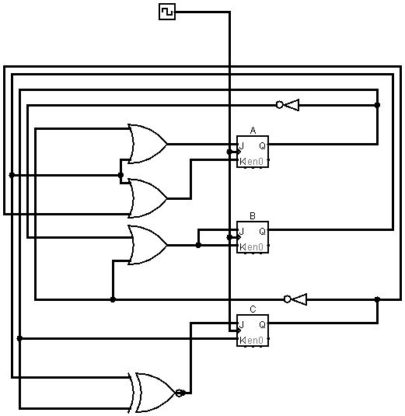

5) Test the system and attach the generated table.

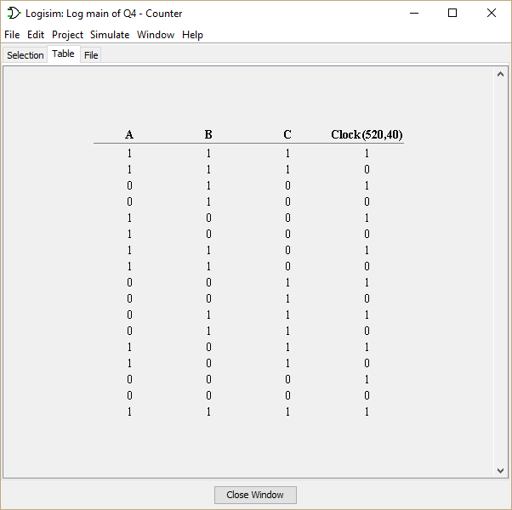

Q5. (2 points) The following circuit is a simple implementation for 4X3 memory chip. In this configuration, your memory chip has four addressable space and each data in the address is 3-bit long. In order to write/read a data into/from a specified address, you have to give a right signal to the address lines, S1 and S0.

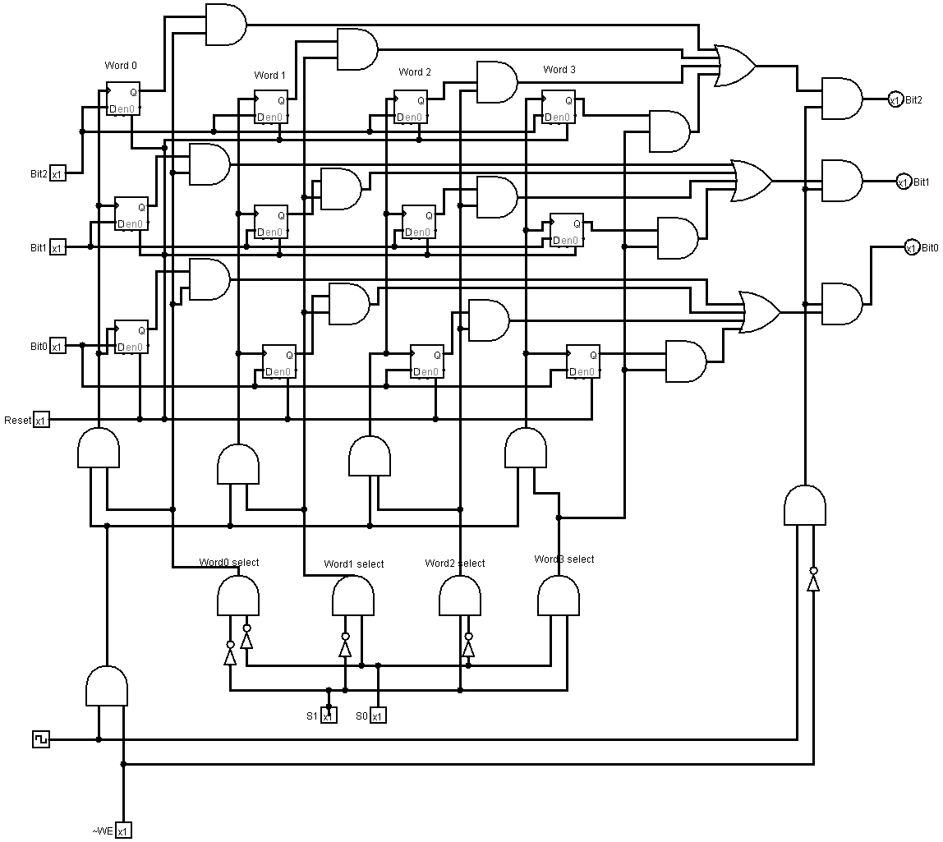

Download the circuit file [4X3 memory.circ](https://canvas.uw.edu/courses/1309355/files/55249344/download?wrap=1) here. And open the circuit file in logisim to test the circuit in Logisim. And answer the following questions:

1) **(1 point)** Suppose you want to write a data 1 0 1 to the word 3 (address 3). How you will set the values in each case?

|  |  |  |  |  |  |  |
| --- | --- | --- | --- | --- | --- | --- |
| **RESET** | **S1** | **S0** | **Bit2** | **Bit1** | **Bit0** | **~WE** |
| **0** | **1** | **1** | **1** | **0** | **1** | **1** |

2) (**1 point**) Suppose you want to read a data from the address 1. Give the correct values in each case. If some bits do not affect, then mark as X (don't care).

|  |  |  |  |  |  |  |
| --- | --- | --- | --- | --- | --- | --- |
| **RESET** | **S1** | **S0** | **Bit2** | **Bit1** | **Bit0** | **~WE** |
| **0** | **0** | **1** | **X** | **X** | **X** | **0** |